CDA 4203L Spring 2018
Computer System Design Lab
Lab 3 – Programmable Counter, BCD Converter and FPGA Synthesis
Handed out on Friday, 7th February
Due Date: 11:59 PM, Sunday, 18th February

Teaming allowed. No more than three (3) members per group.

Objective: To learn and practice advanced sequential hardware design in Verilog and synthesizable Verilog based circuit implementation on FPGA board.
Table 1
Port | Width | I/O | Function
max_count | 7 | I | Set the maximum counter value
run | 1 | I | Set run mode;  0 = set, 1=run
digit_2 | 4 | O | Ten digit BCD output
digit_1 | 4 | O | Ones Digit BCD output
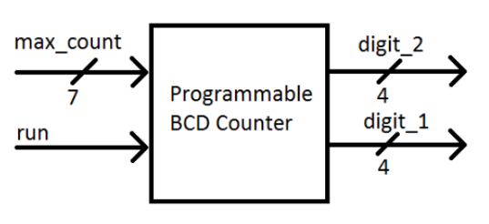

Figure 1: Counter Top-Level Block Diagram

Table 2
Port | Width | I/O | Component | Mapping
Run | 1 | I | Dip Switches | SW7
Max_count | 7 | I | Dip Switches | SW6 (MSB) – SW0 (LSB)
Clk | 1 | I | Dip Switches | USER_CLK
Digit_1 | 4 | O | GPIO LEDS | LED3 (MSB) – LED0 (LSB)
Digit_2 | 4 | O | GPIO LEDS | LED7 (MSB) – LED4 (LSB)

Description:
Design a programmable counter that outputs BCD and has a range of 0-99. The counter must count from zero to a user-input value. The valid input range is 0-99; if a higher number is input, the counter must not output beyond 99 (decimal). The output from your design should be in binary-coded decimal. You will need to design a binary counter that counts at least to 99_{dec}, and a module which converts the binary output to two-digit BCD. A single-bit input, called run, determines the operation of the counter. When run is ‘0’, the counter is set to zero and does not count. The user can set the maximum value here, using an input called max_count. When run is set to ‘1’, the counter starts counting from zero, and stops when it reaches the maximum. Any changes to max_count is ignored when run is set to ‘1’. Your design will have two 4-bit outputs; digit 1 and digit 2. Each is used to output one BCD digit. Digit 2 is the tens digit, digit 1 is the ones digit.

- (30 pts.) Create a Verilog design (See Figure 1) which will provide the required functionality.
- (20 pts.) Exhaustively test the design to ensure that it works under all conditions.
- (20 pts.) Use 100 MHz to synthesize and map the design on ANVYL board using table 2.

Deliverables: (1) A concise PDF report that includes your Verilog code and simulation results; (2) A zipped file of your design files (Verilog Models and test benches.) Include a README file. Organize your files in folders named Problem1, Problem2.

Report Organization (A template is provided on Canvas):
- Cover sheet
- Problem 1 and 2: Verilog Code, Test Bench, and Simulation Results (Waveforms)
- Problem 3: Pin Mapping file
- Feedback: Hours spent, Exercise difficulty (Easy, Medium, Hard)

Important:
- Do not discard your designs. They may be used as starting point for subsequent Labs.
- You need to submit your report on Canvas in PDF format. No hardcopy is needed.
- You need to upload the zipped file of your project folder.

